### Crypto Currency ækvivalenspartionering

SetPricePerUnit

|  |  |
| --- | --- |
| currencyName character length | outcome |
| <= 0 | ArgumentException |
| > 0 | Approved |

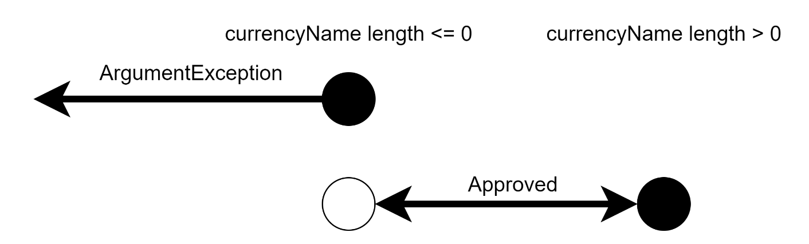

|  |  |
| --- | --- |
| price | Outcome |
| <= 0 | ArgumentException |
| > 0 and <= double.max | Approved |

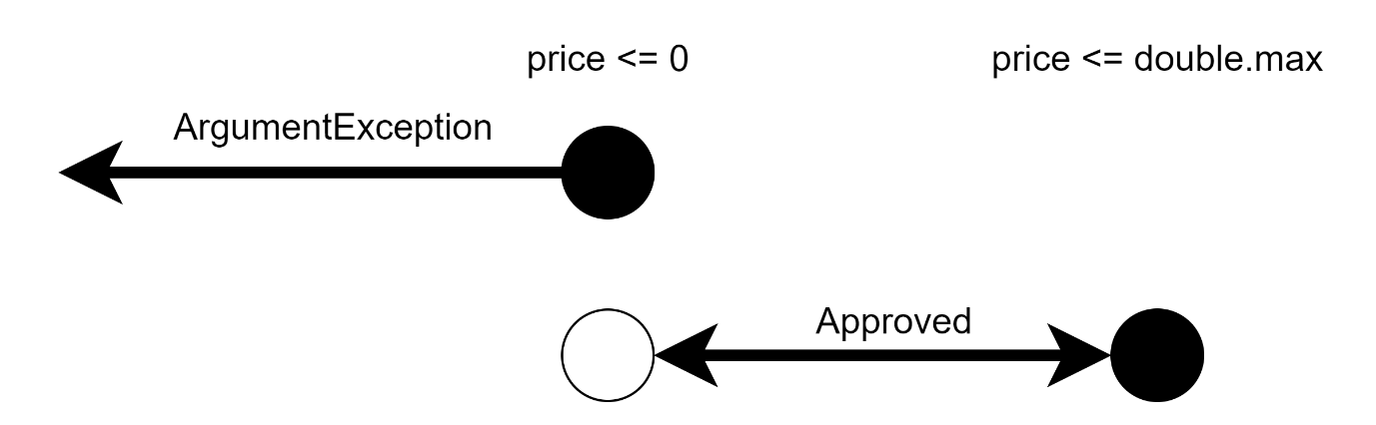

Convert

|  |  |
| --- | --- |
| fromCurrencyName character length | outcome |
| <= 0 | ArgumentException |
| > 0 | Approved |

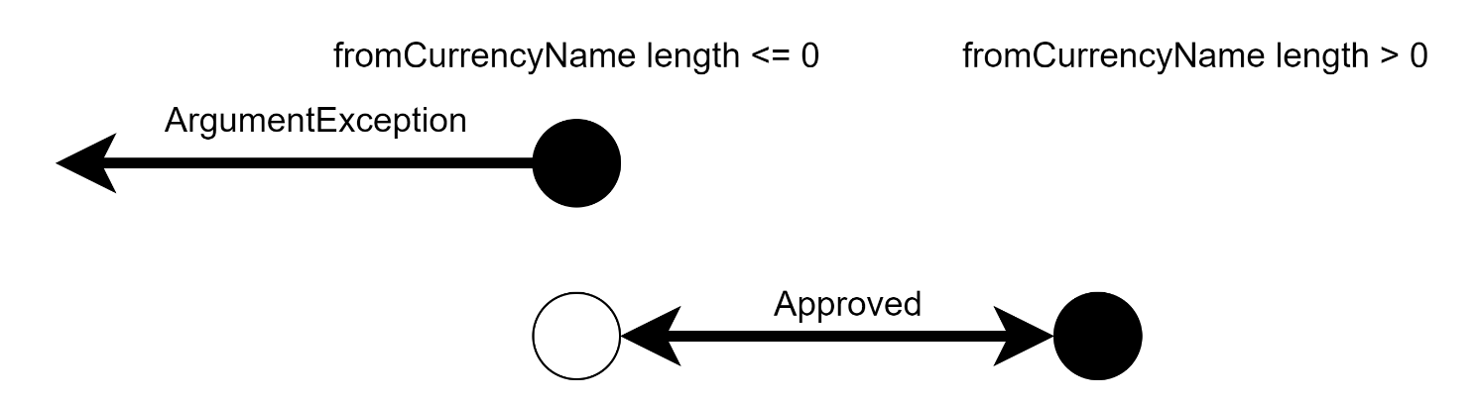

|  |  |
| --- | --- |
| toCurrencyName character length | outcome |
| <= 0 | ArgumentException |
| > 0 | Approved |



|  |  |
| --- | --- |
| amount | Outcome |
| <= 0 | ArgumentException |
| > 0 and <= double.max | Approved |

